Test case scenario flow:

Below is the test case scenario flow proposed by Wipro. Prerequisit condition is that AVP demo is already running.
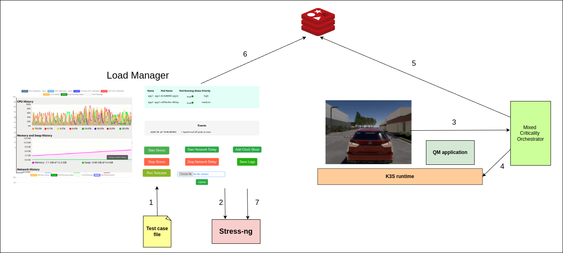
Step 1:
Test case file is loaded into the UI. This file will have following parameters
a) CPU stress value
b) Memory stress value
c) Incremental step size i.e. 1% increment or 10% increment, etc
d) Time between each step i.e. 2 sec delay, 4 sec delay, ...

Step 2:
Once “Run test case” button is clicked, both CPU and Memory stress starts getting applied on the system.

Step 3:
Due to stress AVP hits deadline. This triggers notification to MCO server via a CURL request.

Step 4:
MCO will delete the QM app by giving trigger to kubernetes.

Step 5:
MCO saves the notification that AVP requested for QM deletion in redis database

Step 6:
Load manager will have a seperate thread monitoring for the notification in redis database

Step 7:
Load manager detects the notification and stops the incremental stress which is applied till now.

Note:
Step 3 can be mocked by manually giving a CURL request via terminal. Doing this will decouple AVP demo dependency and the entire testcase flow.

